# **Salient region detection for targeted advertisements placement in videos**

# **Problem Statement**

Placing advertisement in a video is a common problem on internet. General approaches, places advertisement on the lower half of the video, and few video services also place the advertisement right in the middle which covers the entire video viewing. By these advertisements, free video services earn money. So, based on number of clicks on the advertisement, define the money earned by the video service provider. That is earning of the service provider is dependent on the placement of advertisement on right spot on video. In this project we can try a new approach of placing the advertisement in a video, i.e. based on salient region detection. First task is to find the salient region in the video, which can be found using image processing techniques and then second task is to place the advertisement on that region. The next section have some background work on salient region detection on images and videos.

# **Background**

As we already discussed two methods of placing advertisements on video, there are other methods which focus on placing advertisement around the video content, that is the advertisement is placed outside the video frame. The next part is salient region detection.

Salient region detection started with fixation prediction and training models to estimate the eye fixation behaviour of human. For fixation prediction many approaches like local patch convolution, fixation map method, local contrast method, global statistics and etc. Then it is also used in surveillance videos to find human activity. It is also used in video compressing, by compressing non-salient portion of video. There are many machine learning approaches which require labelled data, that is what pixels are salient in the image or frame.

The approach that we can follow does not require machine learning, or any dataset, by just using image processing we can find the salient region. This will help us to reduce the time consumption of prediction. All the processing can be done on real time, as this project does not require any fast response, it can work very efficient for this problem.

# **Methodology**

Following are the steps to find the salient region and then placing the advertisement on it.

Step 1: Using Bayesian Saliency Formulation for distinguishing between foreground and background.

Step 2: Then we divide each frame into bins of some specific size to estimate joint distribution, this process is also called as encoding. This will create histogram structures of encoding vectors.

Step 3: Computing local foreground saliency using Saliency Map computation. Beside local saliency map, we can also compute global saliency foreground maps which can provide some overview information.

Step 4: Then we can find Motion information which will help in finding the noise created by motion. Then we can remove that noise from the frames. It can be performed by pseudo-color optical flow algorithm.

Step 5: Then we combine the Local Saliency Maps with Global Saliency Maps and Motion Information to find the salient region from the video.

Step 6: Extract the pixel of salient region and place the advertisement banner over it. The image should have a background algorithm which will help viewer to remove the advertisement on will.

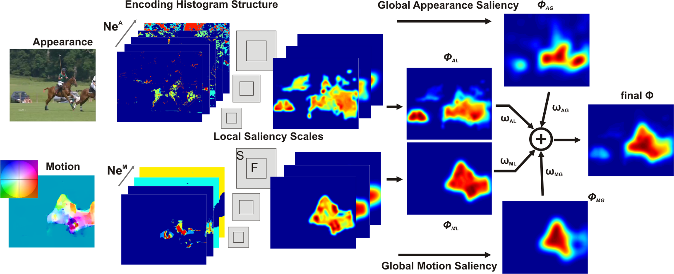

Figure 1: Overview of the approach (from left to right) ["Encoding based Saliency Detection for Videos and Images" by Thomas Mauthner, Horst Possegger, Georg Waltner, Horst Bischof. In IEEE Xplore 2015.]

# **Experimental Design**

***Evaluation Measures:***The evaluation can be done using F1 scores, this measurement can help to understand whether the algorithm will work properly in real world scenario.

***Software and Hardware Requirements:*** Python based Computer Vision will be exploited for the development and experimentation of the project. Tools such as Anaconda Python, and libraries such as OpenCV can be utilized for this process. MATLAB can also be used to implement the algorithm.